**Visitor Station**

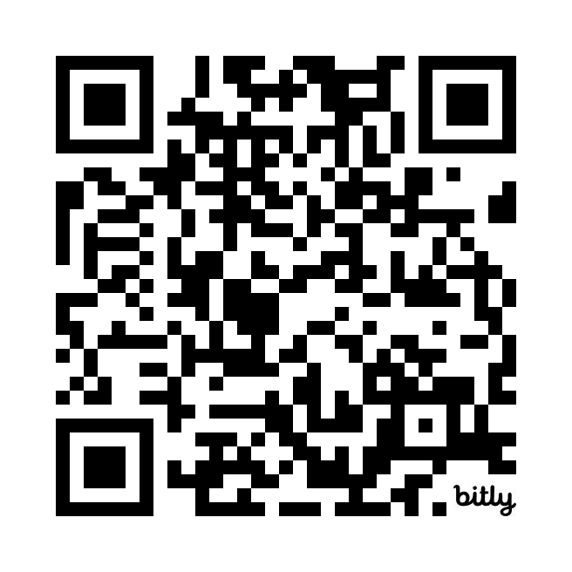

**Welcome!**